RETURN WITH PO

Home and 1 more page - Personal - Microsoft​ Edge

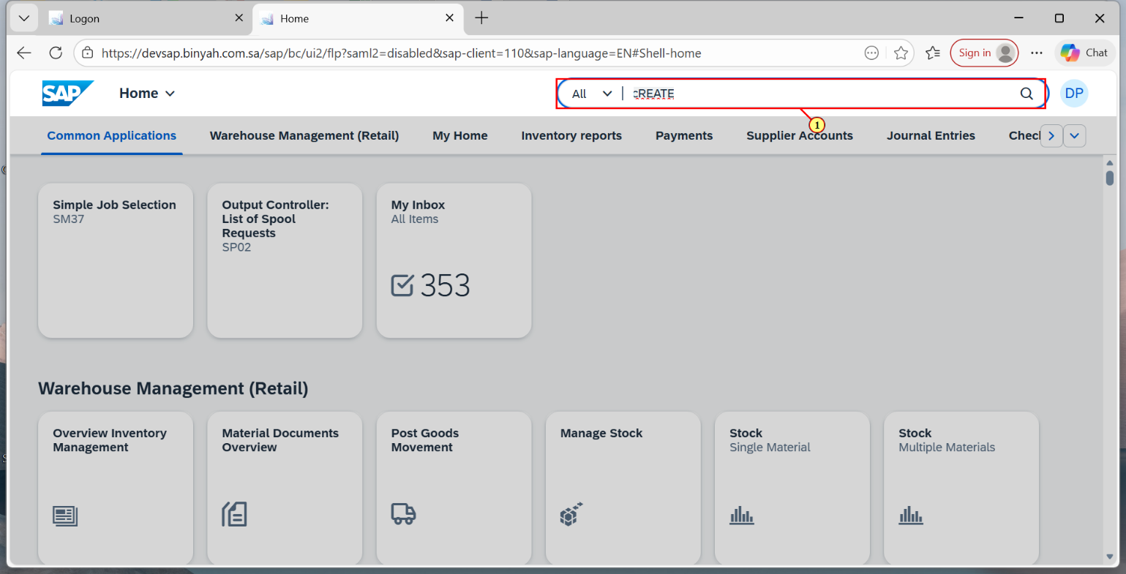

| Step | Action |
| --- | --- |
| (1) | Search and Open "Create Purchase Order-Advanced". |

Create Purchase Order and 1 more page - Personal - Microsoft​ Edge

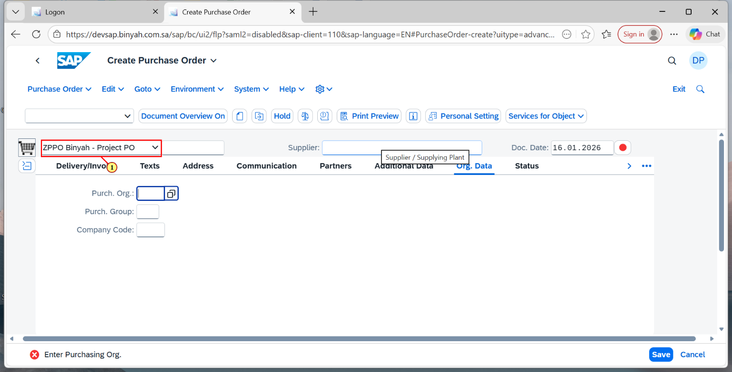

| Step | Action |
| --- | --- |
| (1) | Select the "Document Type". |

Create Purchase Order and 1 more page - Personal - Microsoft​ Edge

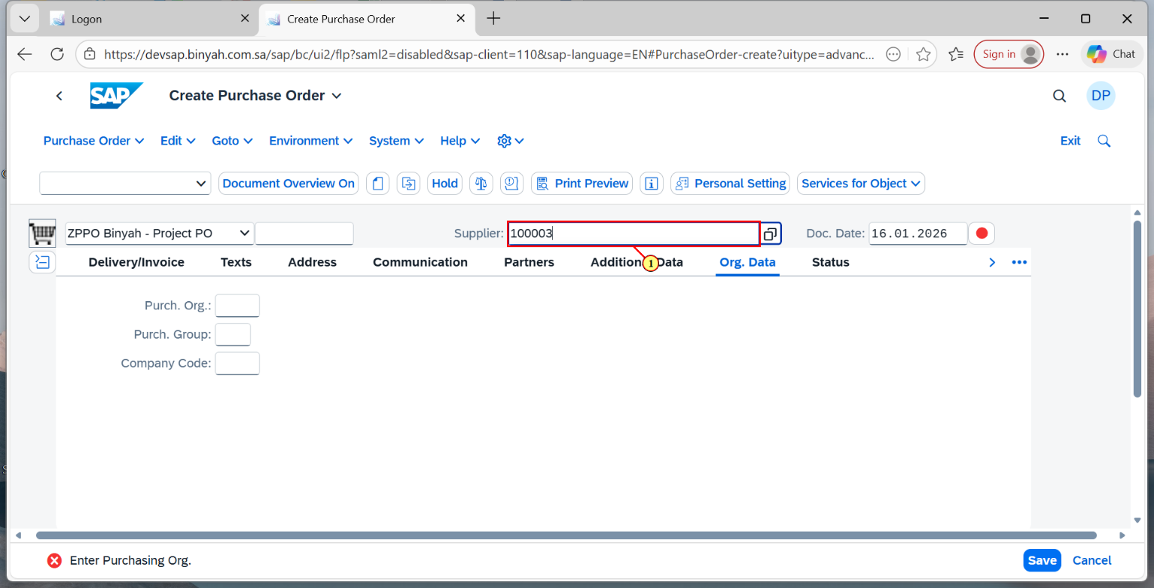

| Step | Action |
| --- | --- |
| (1) | Enter "Supplier". |

Create Purchase Order and 1 more page - Personal - Microsoft​ Edge

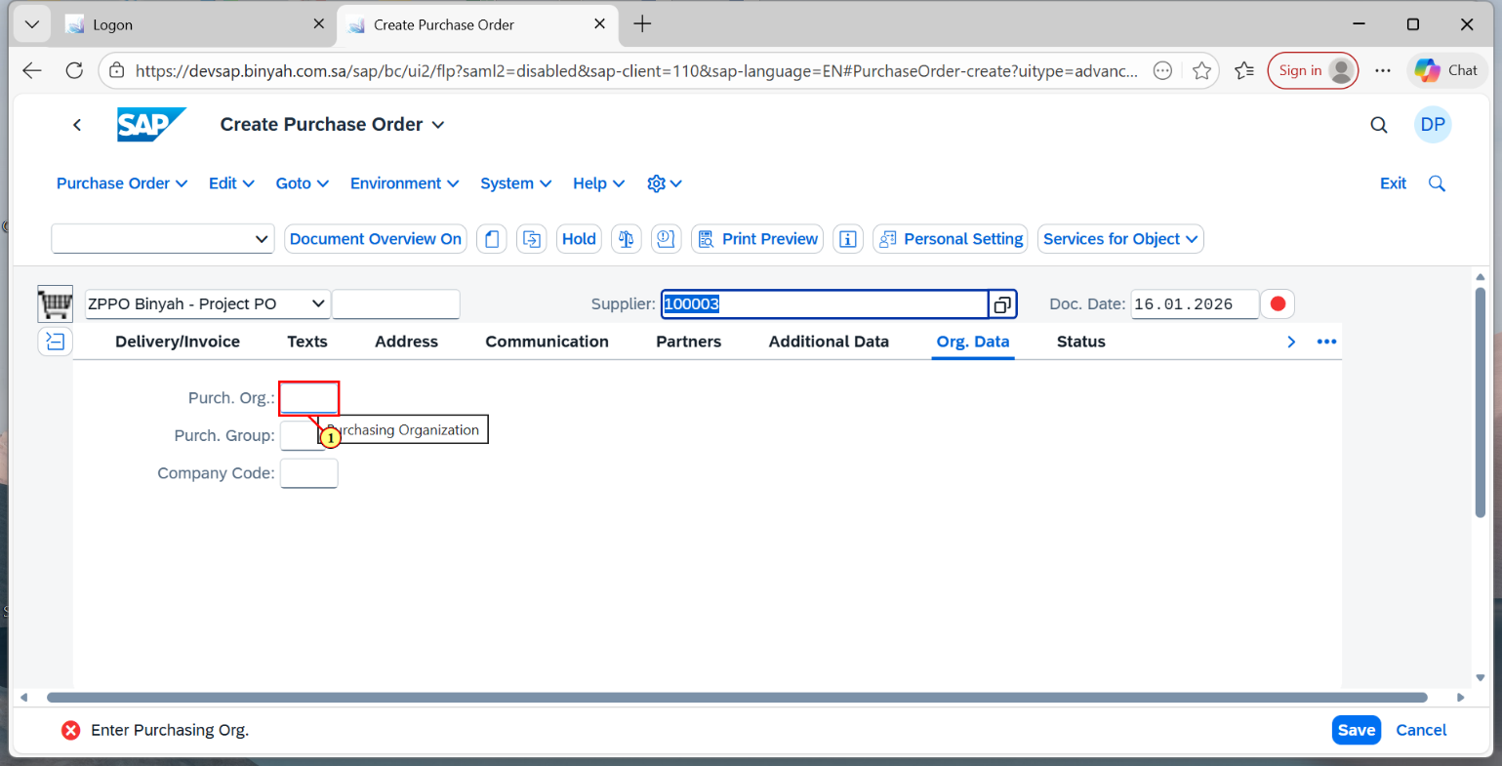

| Step | Action |
| --- | --- |
| (1) | Enter "Purchase Organization". |

Create Purchase Order and 1 more page - Personal - Microsoft​ Edge

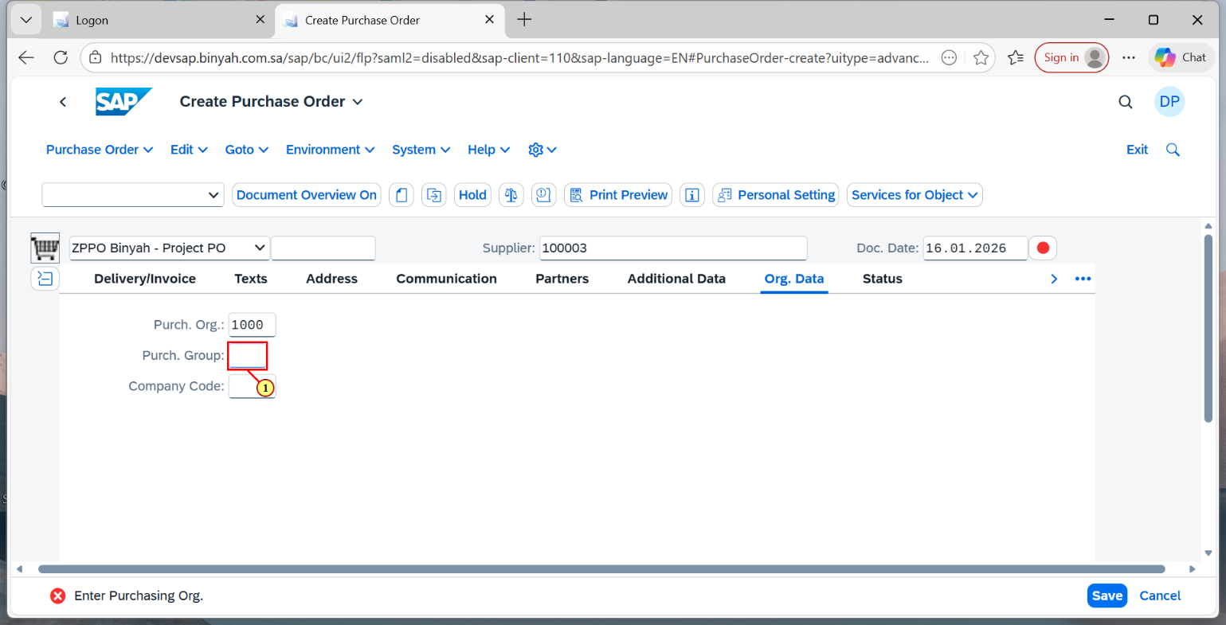

| Step | Action |
| --- | --- |
| (1) | Enter "Purchase Group". |

Create Purchase Order and 1 more page - Personal - Microsoft​ Edge

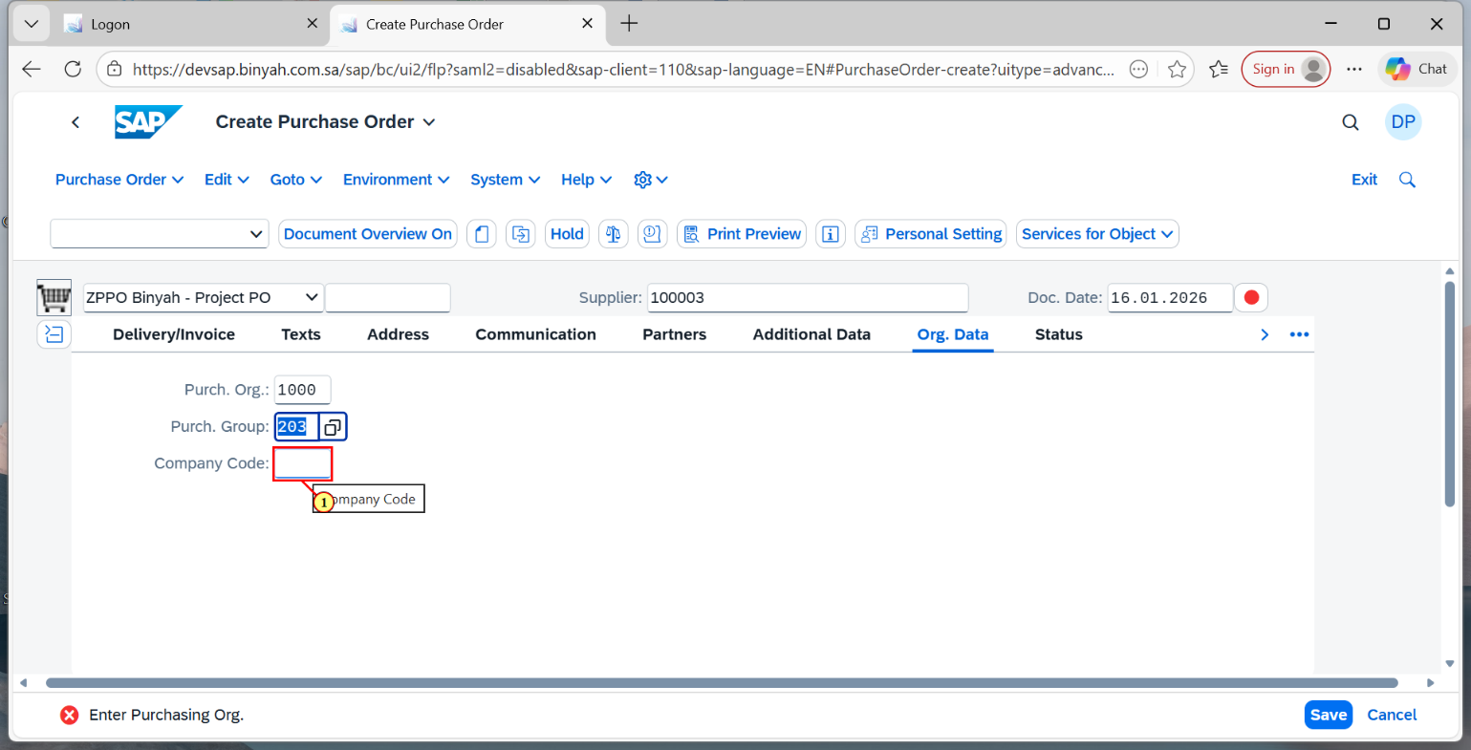

| Step | Action |
| --- | --- |
| (1) | Enter "Company Code". |

Create Purchase Order and 1 more page - Personal - Microsoft​ Edge

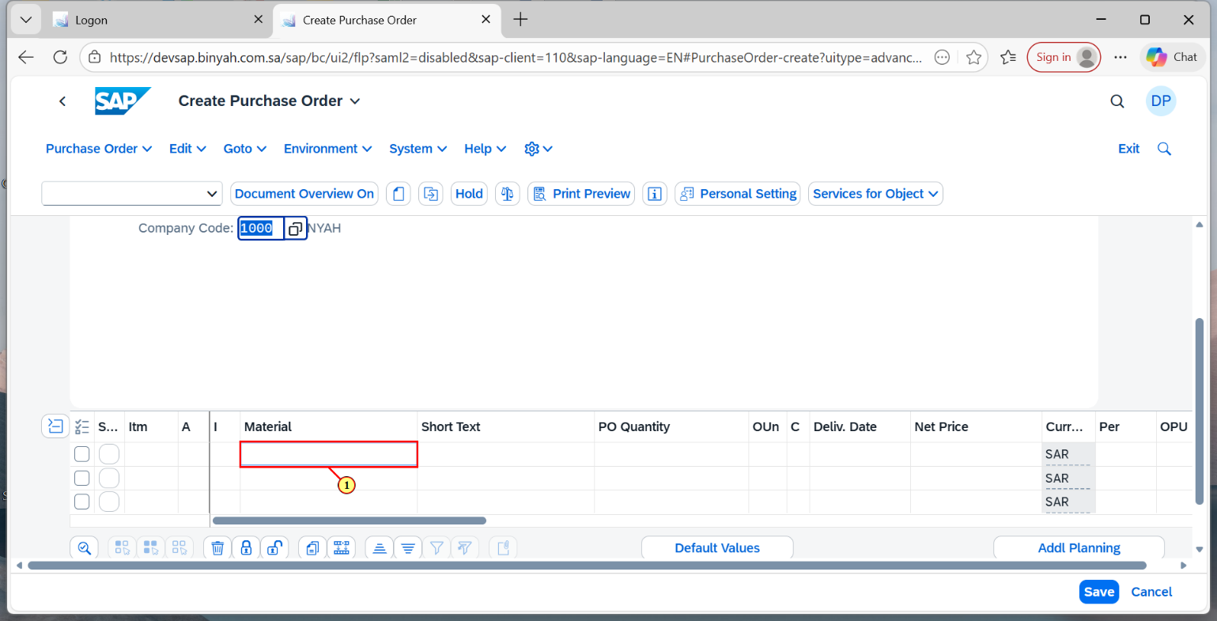

| Step | Action |
| --- | --- |
| (1) | Enter "Material". |

Create Purchase Order and 1 more page - Personal - Microsoft​ Edge

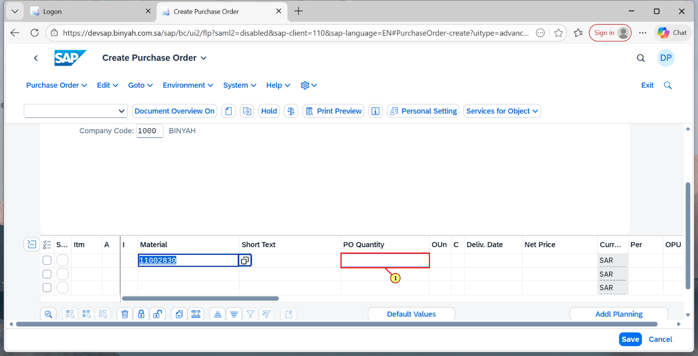

| Step | Action |
| --- | --- |
| (1) | Enter "Quantity". |

Create Purchase Order and 1 more page - Personal - Microsoft​ Edge

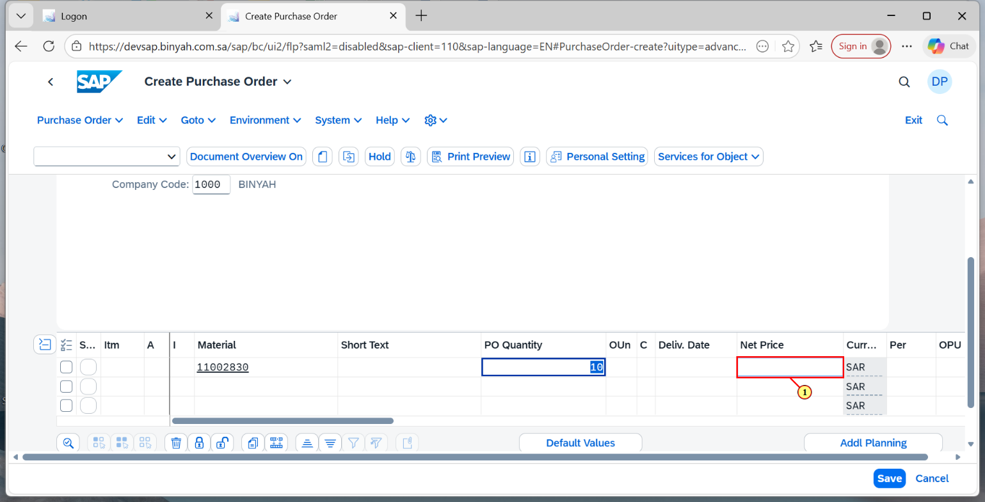

| Step | Action |
| --- | --- |
| (1) | Enter "Net Price". |

Create Purchase Order and 1 more page - Personal - Microsoft​ Edge

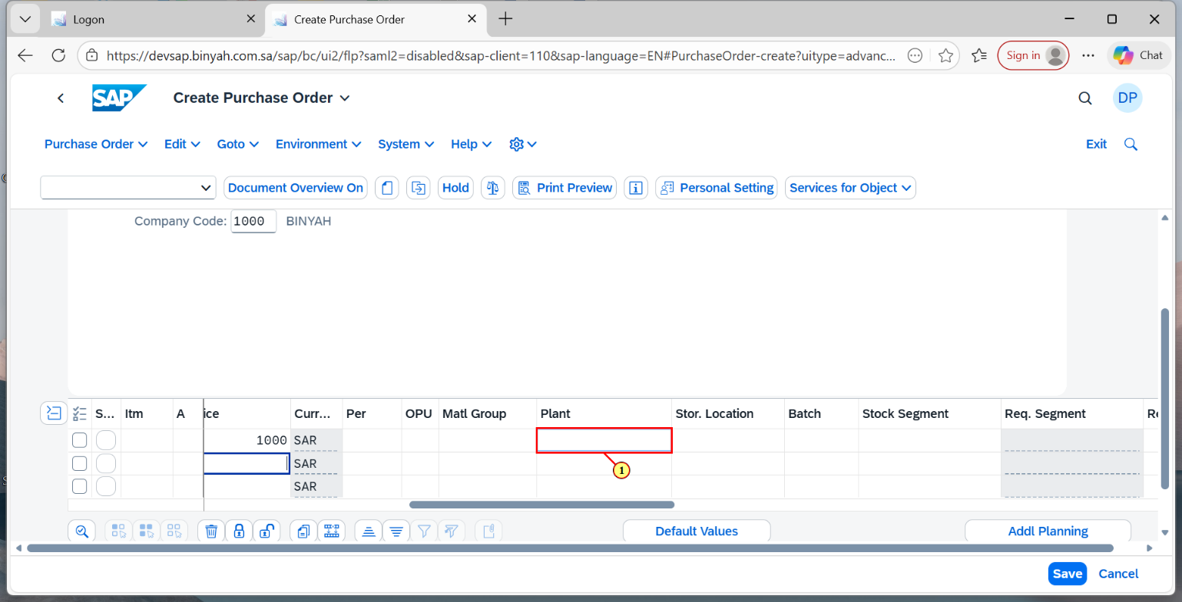

| Step | Action |
| --- | --- |
| (1) | Enter "Plant". |

Create Purchase Order and 1 more page - Personal - Microsoft​ Edge

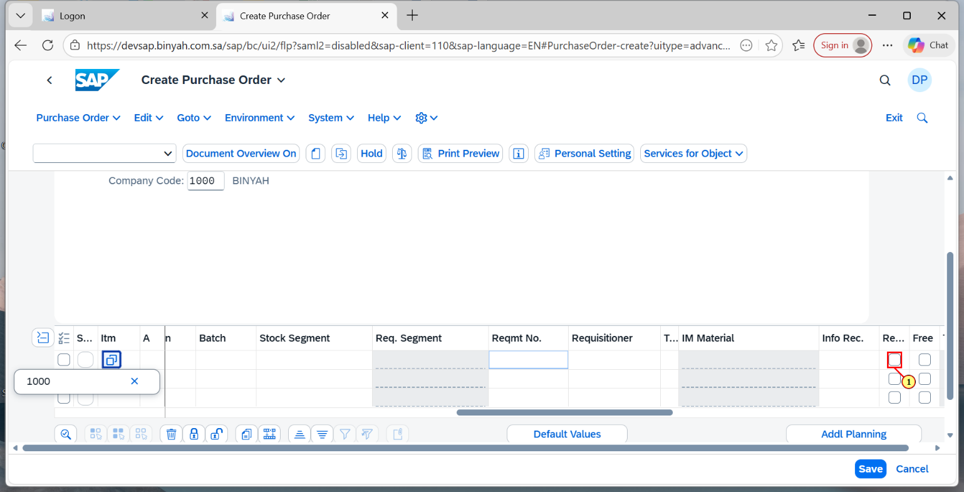

| Step | Action |
| --- | --- |
| (1) | Click on "Returns Item" Checkbox. |

Create Purchase Order and 1 more page - Personal - Microsoft​ Edge

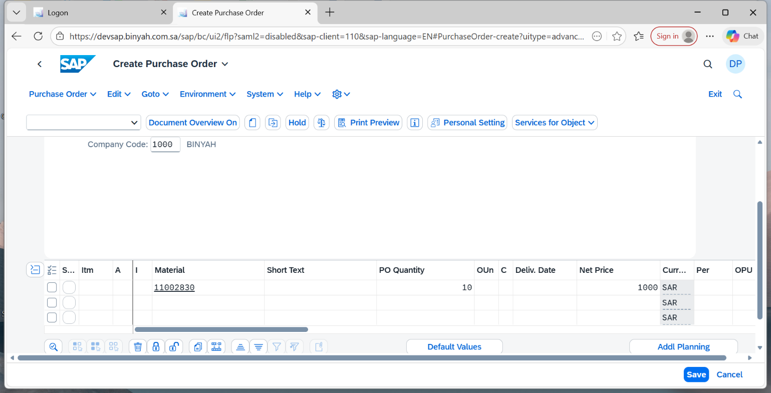

| Step | Action |
| --- | --- |
|  | Press "Enter". |

Create Purchase Order and 1 more page - Personal - Microsoft​ Edge

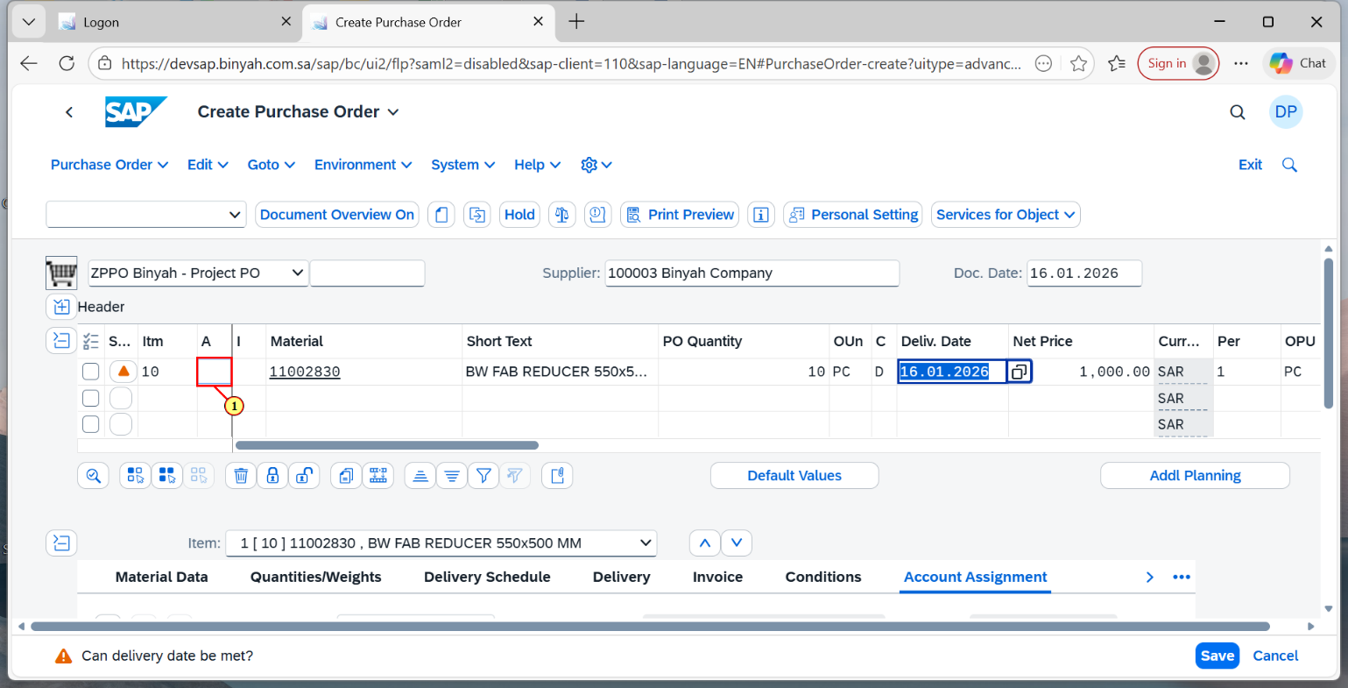

| Step | Action |
| --- | --- |
| (1) | Enter "Account Assignment". |

Create Purchase Order and 1 more page - Personal - Microsoft​ Edge

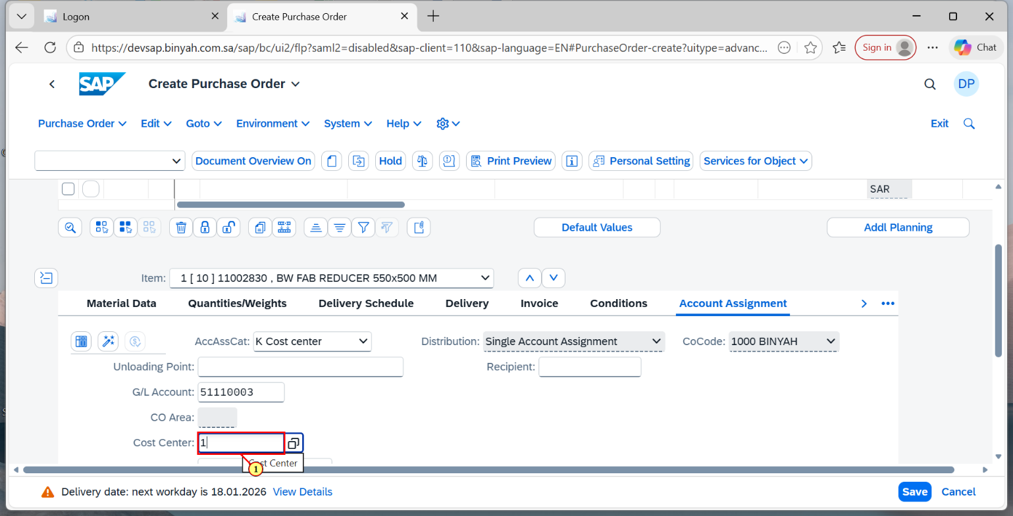

| Step | Action |
| --- | --- |
| (1) | In Account Assignment Section Enter "Cost Center". |

Create Purchase Order and 1 more page - Personal - Microsoft​ Edge

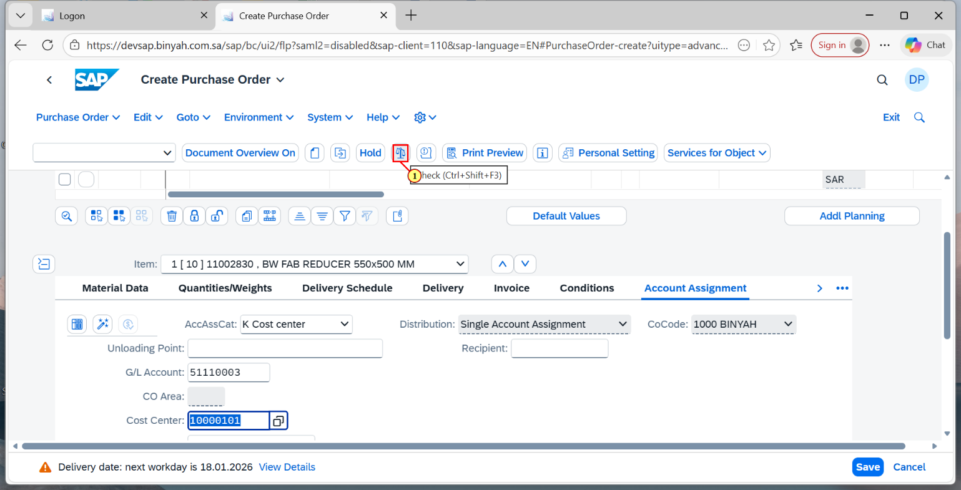

| Step | Action |
| --- | --- |
| (1) | Click on "Check". |

Create Purchase Order and 1 more page - Personal - Microsoft​ Edge

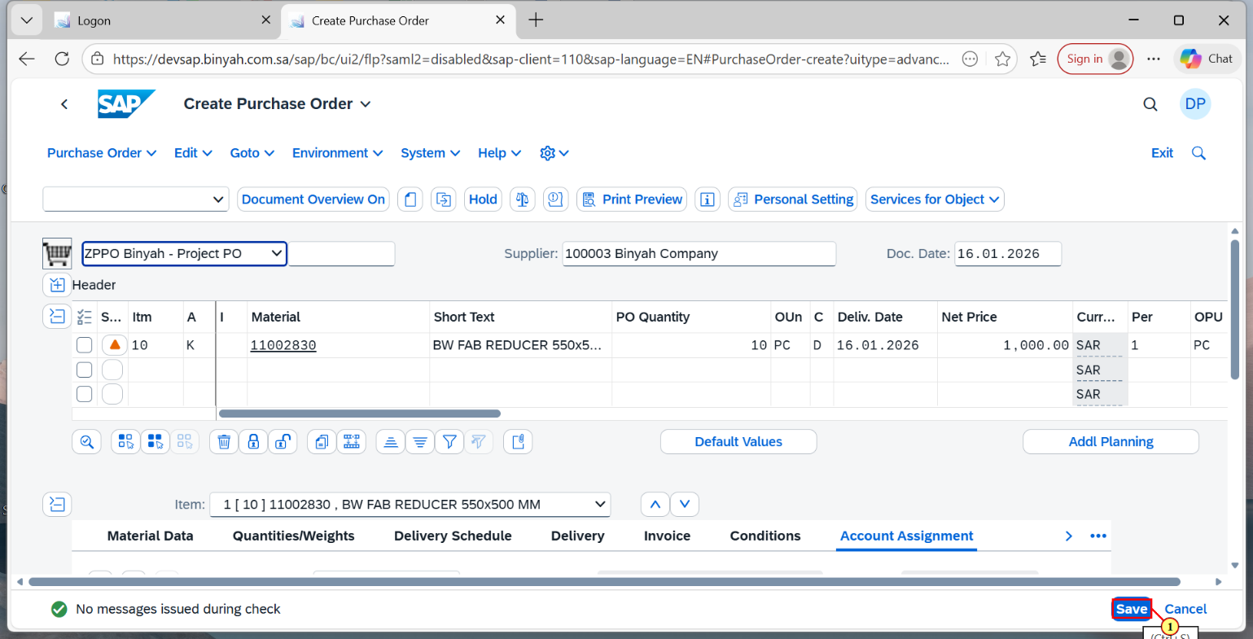

| Step | Action |
| --- | --- |
| (1) | Click on "Save". |

Home and 1 more page - Personal - Microsoft​ Edge

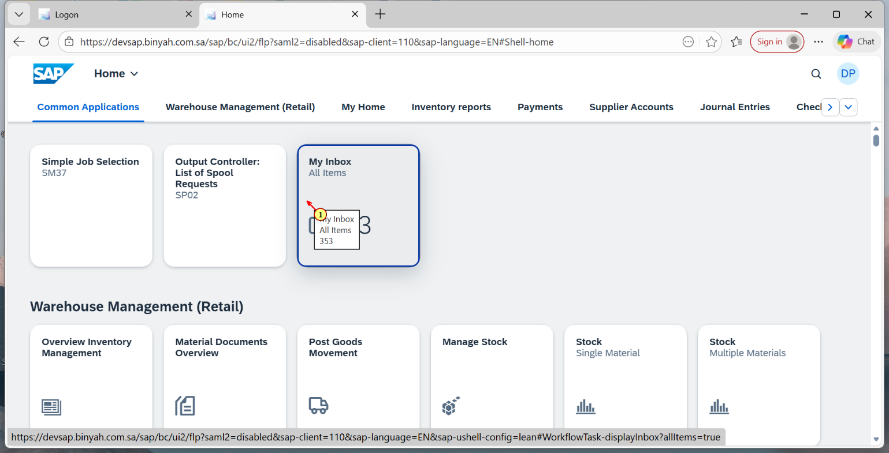

| Step | Action |
| --- | --- |
| (1) | Click on "Inbox" at Home . |

My Inbox and 1 more page - Personal - Microsoft​ Edge

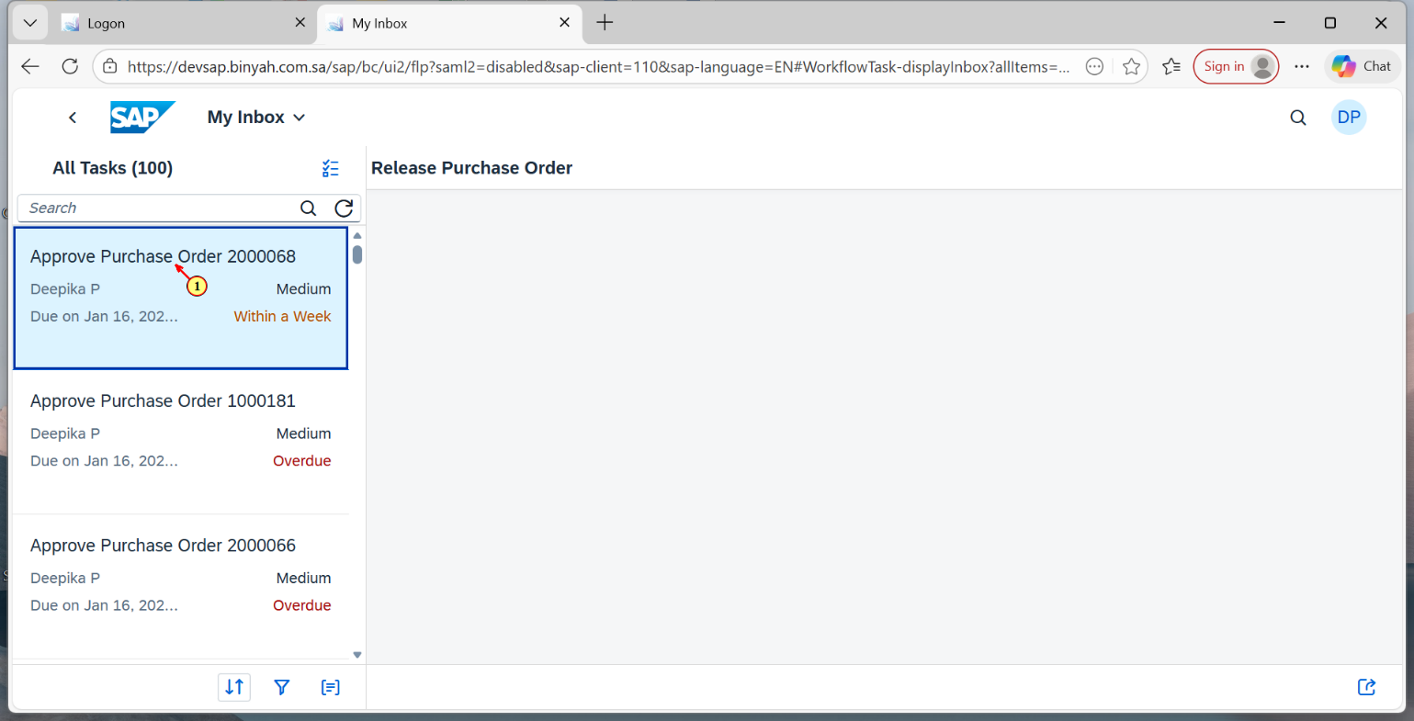

| Step | Action |
| --- | --- |
| (1) | Click on the PO that we have created now. |

Purchase Order and 1 more page - Personal - Microsoft​ Edge

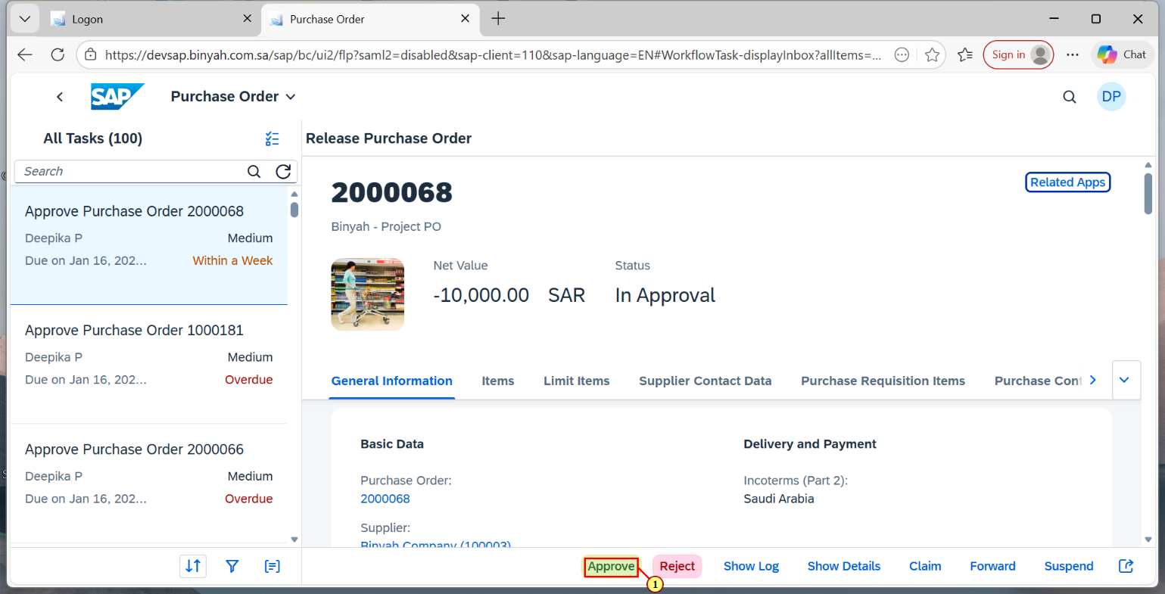

| Step | Action |
| --- | --- |
| (1) | Click on "Approve". |

Purchase Order and 1 more page - Personal - Microsoft​ Edge

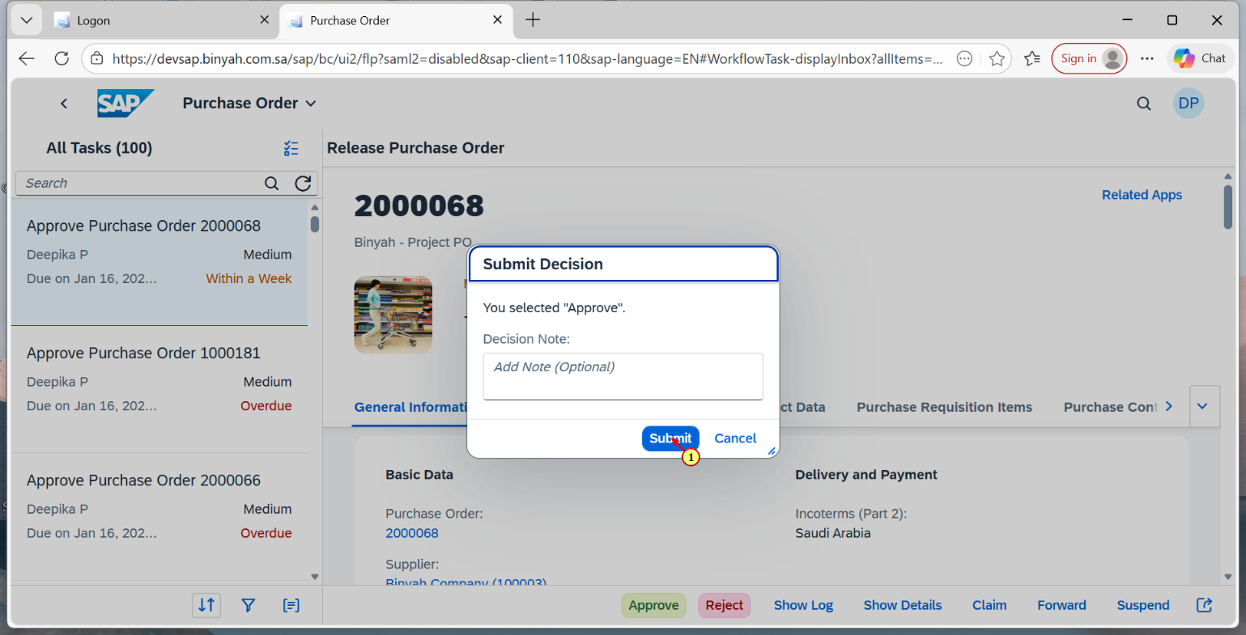

| Step | Action |
| --- | --- |
| (1) | Click on "Submit". |

Home and 1 more page - Personal - Microsoft​ Edge

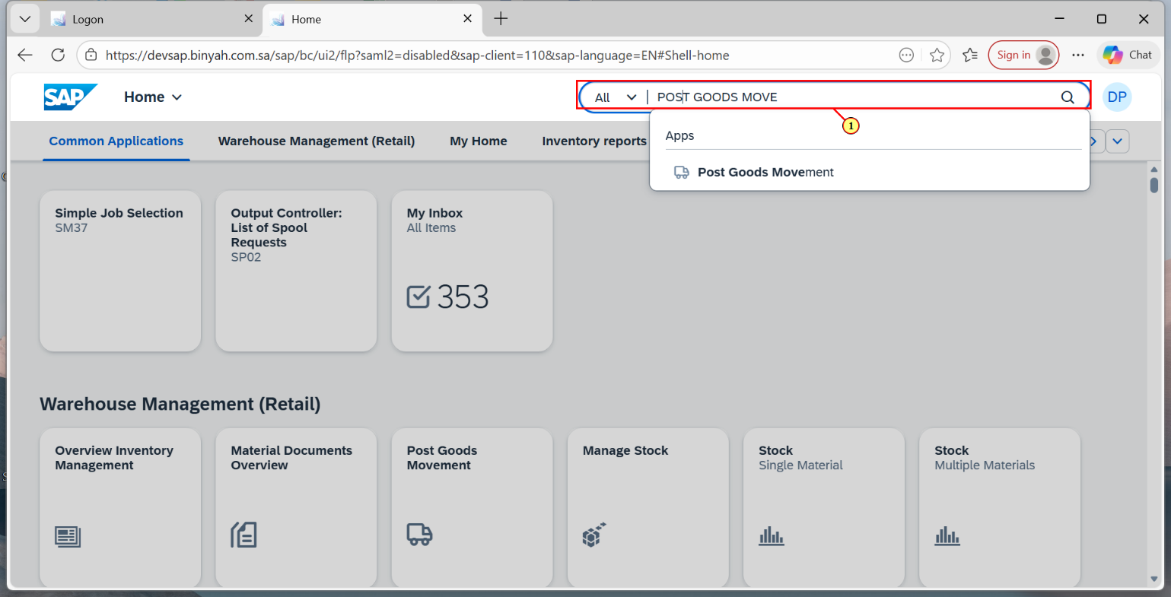

| Step | Action |
| --- | --- |
| (1) | Search and Open "Post Goods Movement". |

Goods Receipt Purchase Order and 1 more page - Personal - Microsoft​ Edge

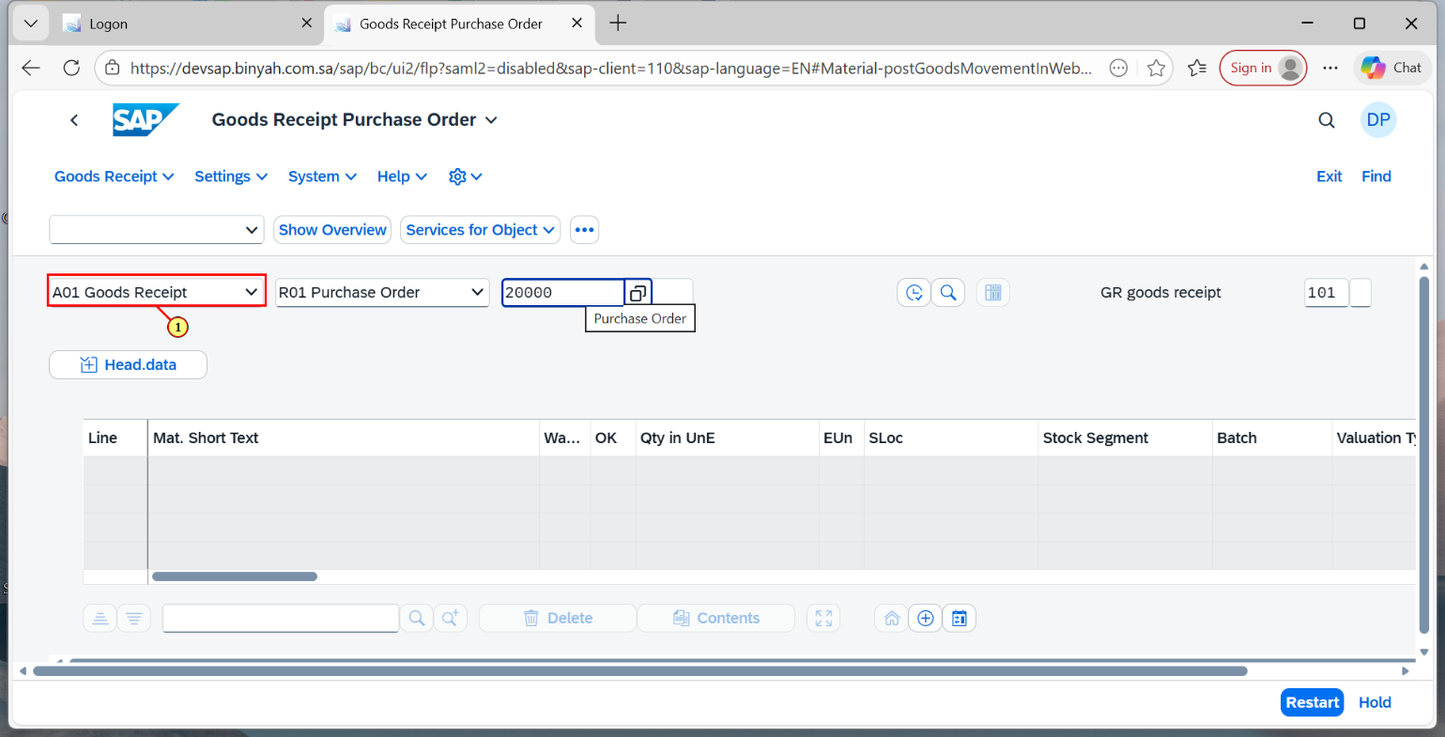

| Step | Action |
| --- | --- |
| (1) | Choose "Goods Receipt" and "Purchase Order". |

Goods Receipt Purchase Order and 1 more page - Personal - Microsoft​ Edge

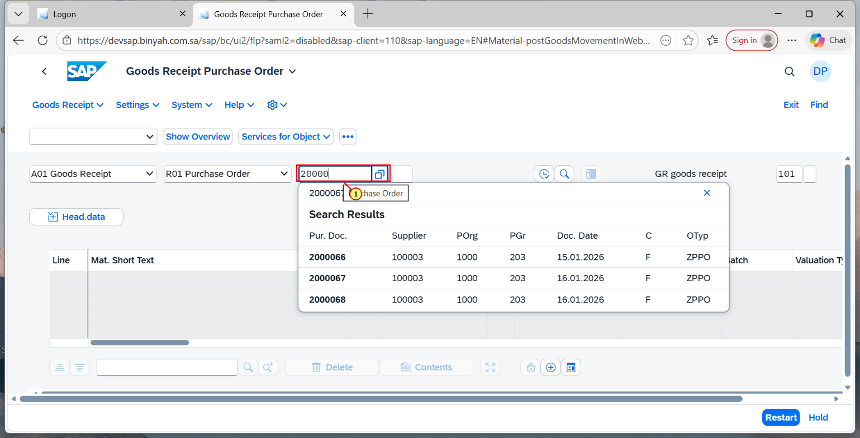

| Step | Action |
| --- | --- |
| (1) | Enter "Purchase Order" Number. |

Goods Receipt Purchase Order and 1 more page - Personal - Microsoft​ Edge

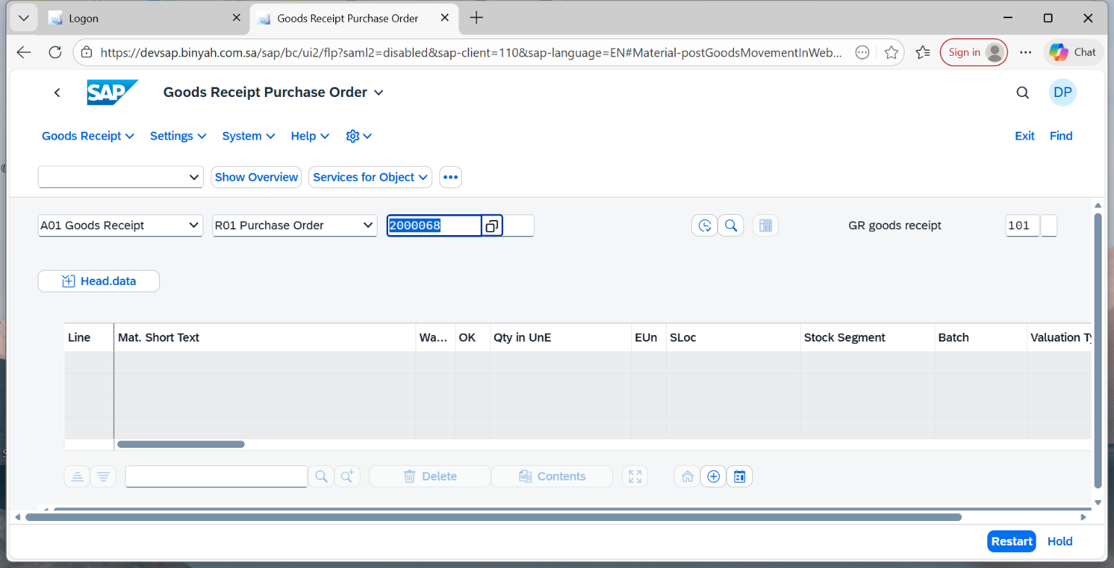

| Step | Action |
| --- | --- |
|  | Press "Enter". |

Goods Receipt Purchase Order 2000068 and 1 more page - Personal - Microsoft​ Edge

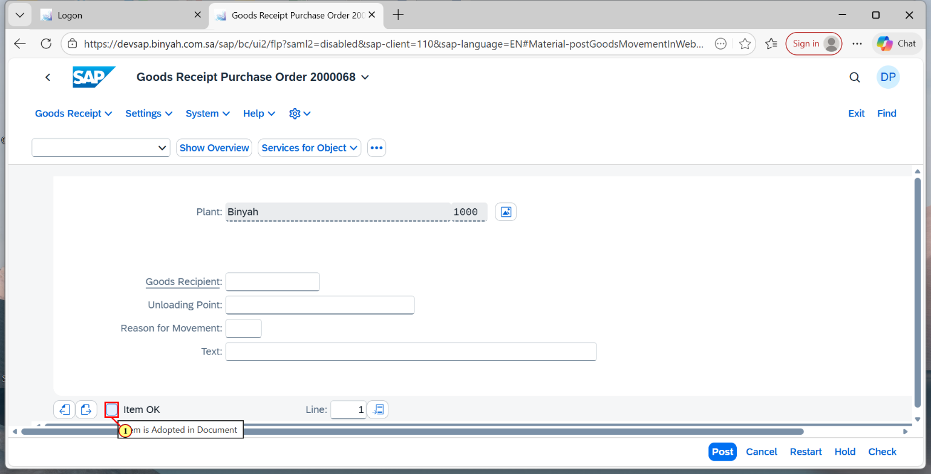

| Step | Action |
| --- | --- |
| (1) | Click  on "Item Ok". |

Goods Receipt Purchase Order 2000068 and 1 more page - Personal - Microsoft​ Edge

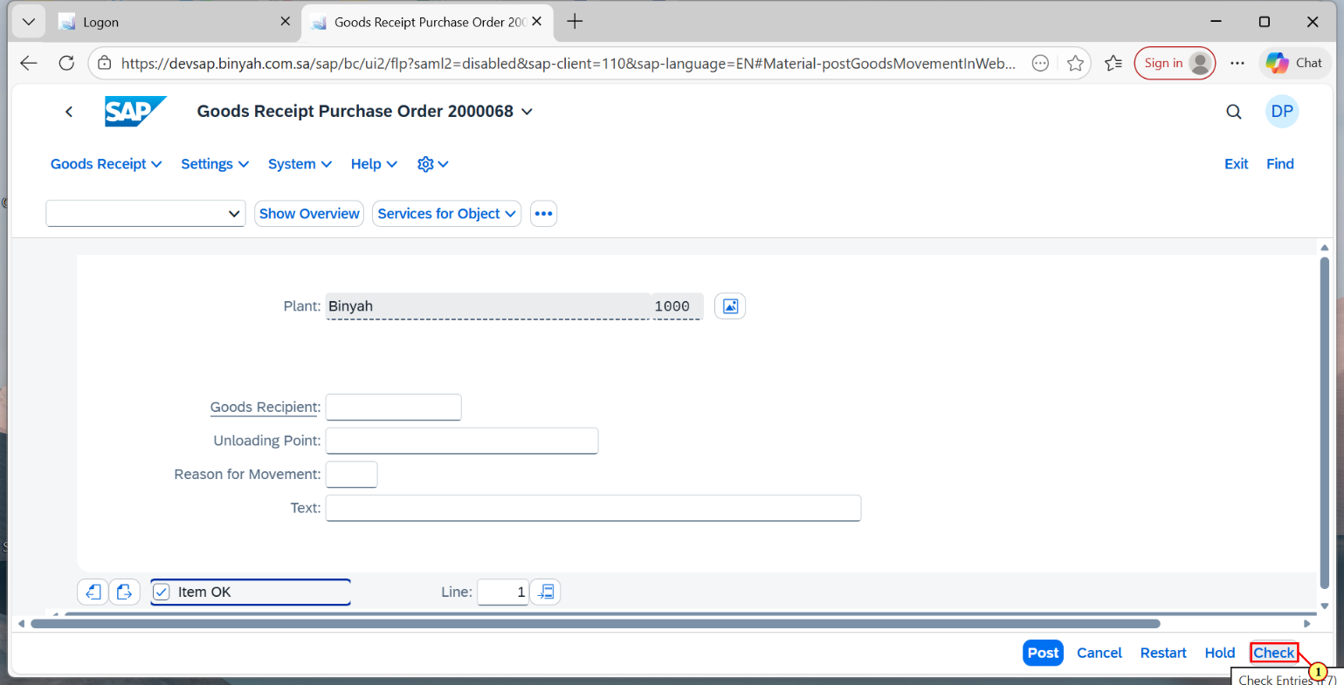

| Step | Action |
| --- | --- |
| (1) | Click on "Check". |

Goods Receipt Purchase Order 2000068 and 1 more page - Personal - Microsoft​ Edge

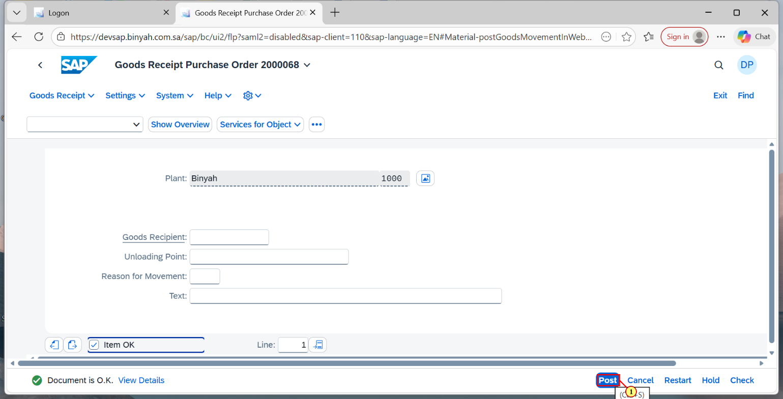

| Step | Action |
| --- | --- |
| (1) | Click on "Post". |

Home and 1 more page - Personal - Microsoft​ Edge

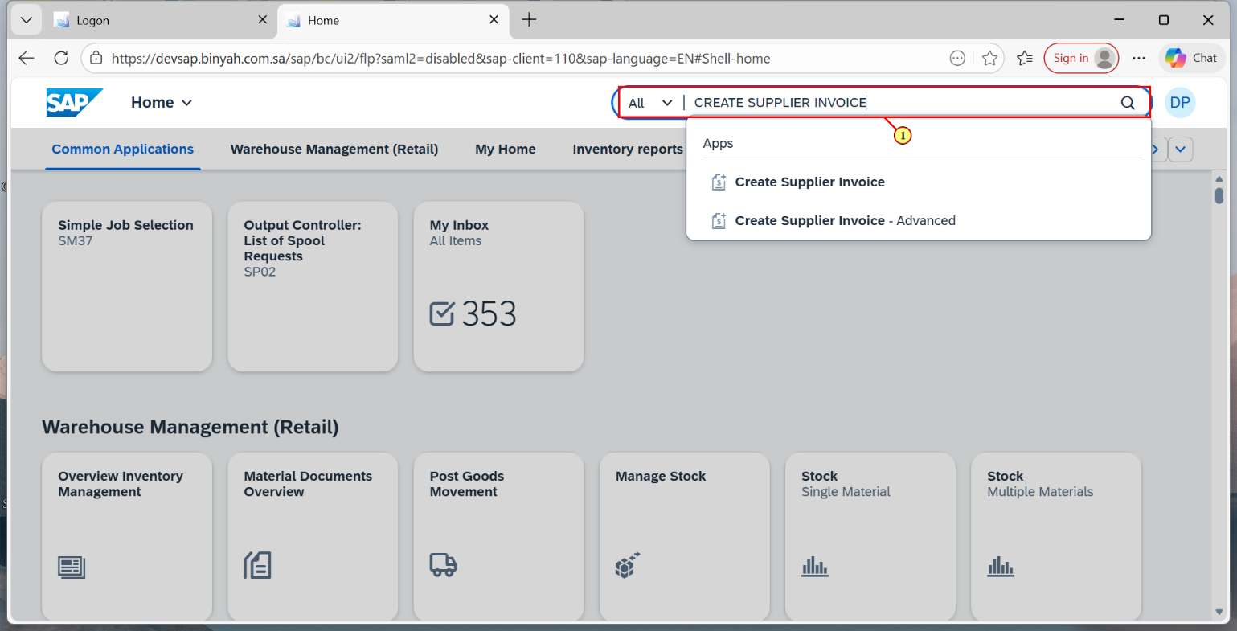

| Step | Action |
| --- | --- |
| (1) | Search and Open "Create Supplier Invoice". |

Create Supplier Invoice and 1 more page - Personal - Microsoft​ Edge

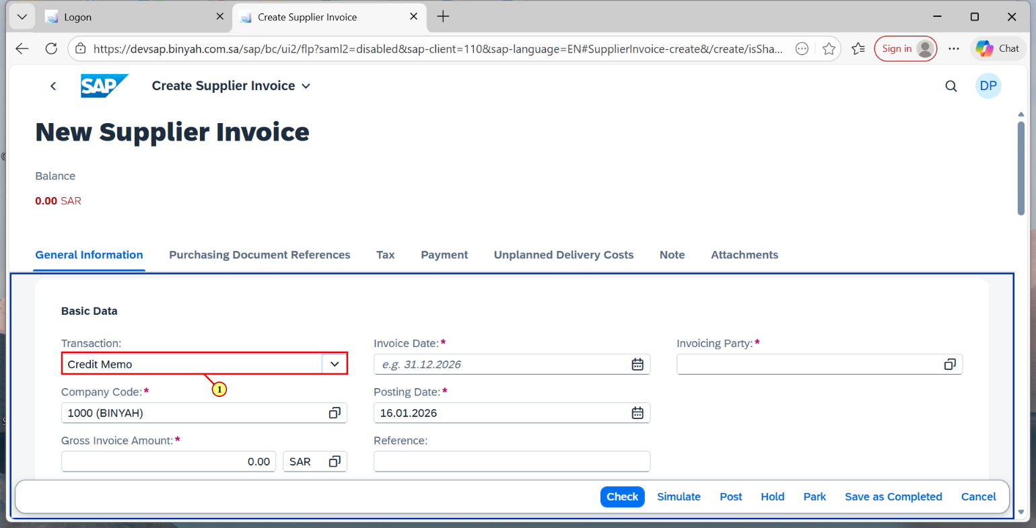

| Step | Action |
| --- | --- |
| (1) | Choose "Credit Memo". |

Create Supplier Invoice and 1 more page - Personal - Microsoft​ Edge

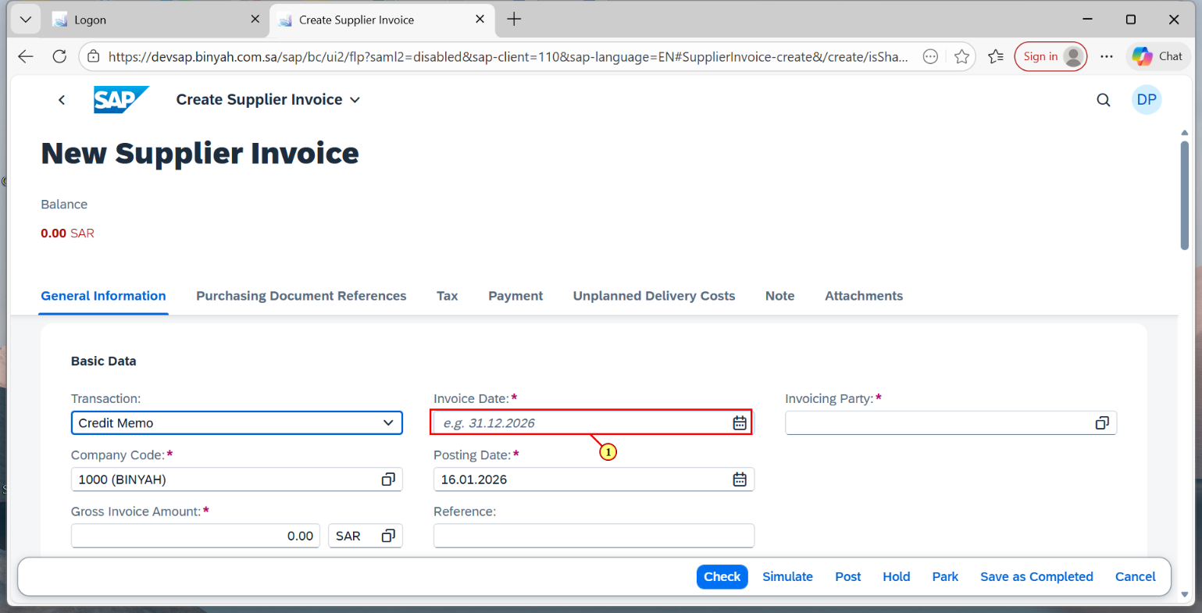

| Step | Action |
| --- | --- |
| (1) | Choose "Invoice Date". |

Create Supplier Invoice and 1 more page - Personal - Microsoft​ Edge

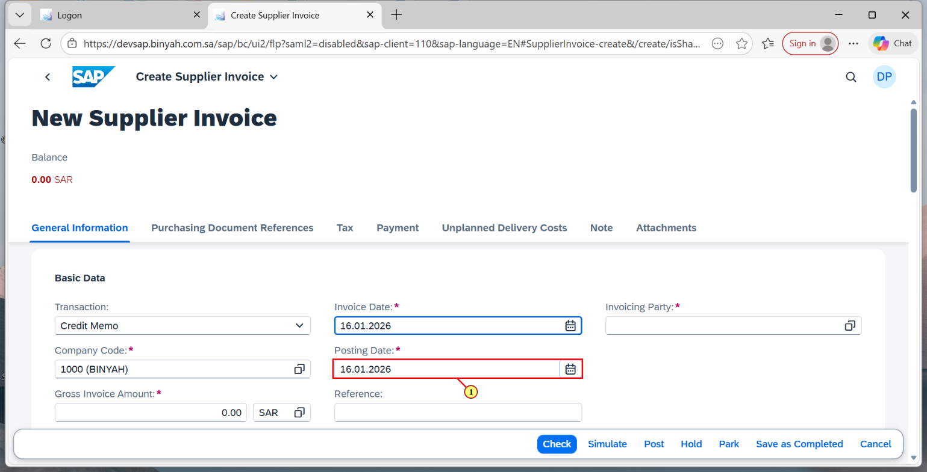

| Step | Action |
| --- | --- |
| (1) | Choose "Posting Date". |

Create Supplier Invoice and 1 more page - Personal - Microsoft​ Edge

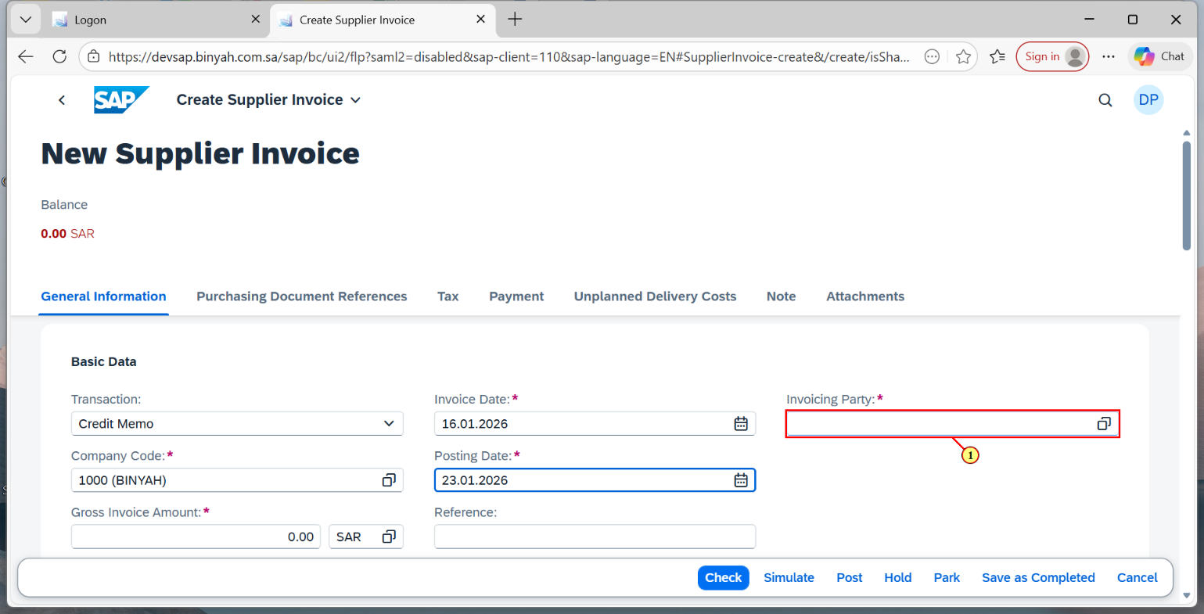

| Step | Action |
| --- | --- |
| (1) | Choose "Invoice Party". |

Create Supplier Invoice and 1 more page - Personal - Microsoft​ Edge

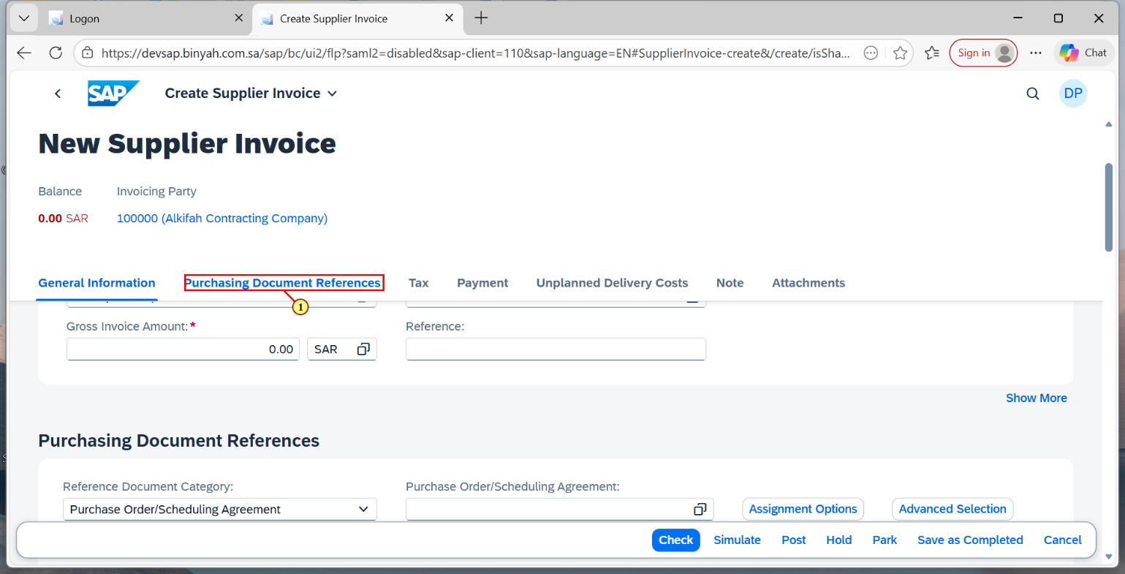

| Step | Action |
| --- | --- |
| (1) | Click on "Purchasing Document References". |

Create Supplier Invoice and 1 more page - Personal - Microsoft​ Edge

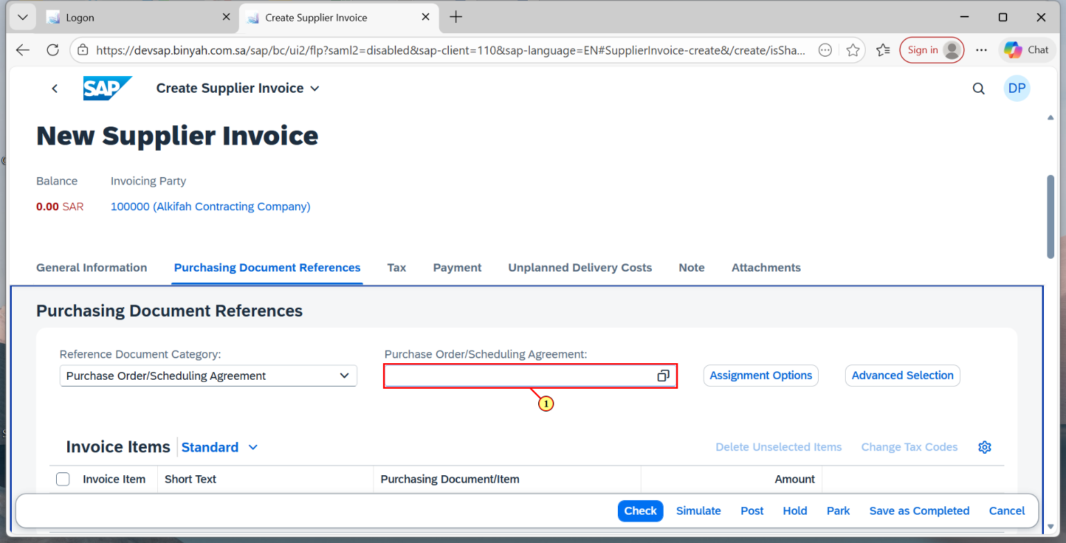

| Step | Action |
| --- | --- |
| (1) | Enter the "Purchase Order" Number. |

Create Supplier Invoice and 1 more page - Personal - Microsoft​ Edge

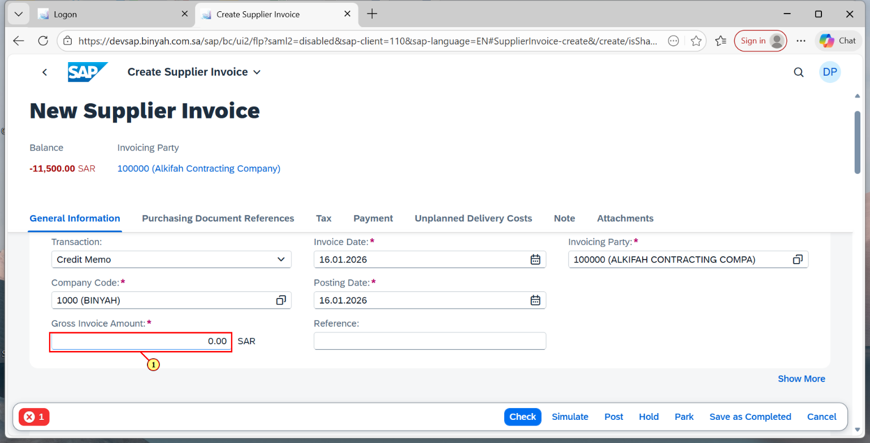

| Step | Action |
| --- | --- |
| (1) | Now in Basic Data tab Enter the Gross Invoice Amount same as Balance Displayed on the Top. |

Create Supplier Invoice and 1 more page - Personal - Microsoft​ Edge

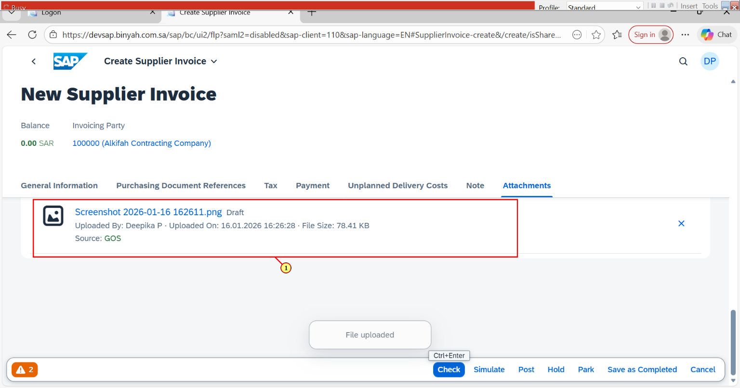

| Step | Action |
| --- | --- |
| (1) | In Attachment tab click on "Upload" and upload the invoice file. |

Create Supplier Invoice and 1 more page - Personal - Microsoft​ Edge

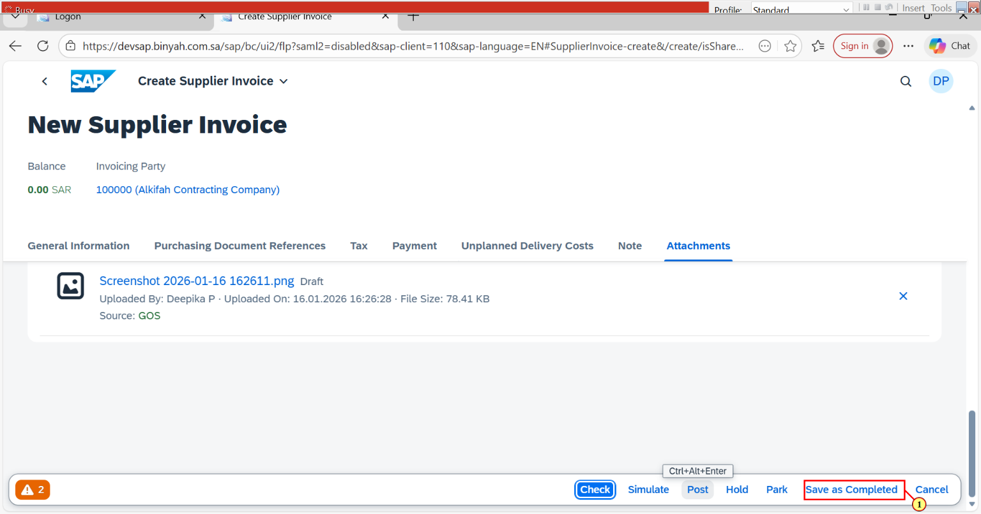

| Step | Action |
| --- | --- |
| (1) | Click on "Save as Completed" |